

TDS 3751 Social Media Computing

Assignment 3

Social Network Analysis

Report

Prepared by:

|  |  |  |  |  |
| --- | --- | --- | --- | --- |
| Name | ID | Tutorial Section | Email | Phone No. |
| Lim You Qian | 1141128343 | TT02 | limyq0202@gmail.com | 019 - 383 9366 |
| Kew Wai Chun | 1141128080 | TT02 | 1141128080@student.mmu.edu.my | 016 - 203 2189 |
| Kevin Toh Huat Xiang | 1141128390 | TT02 | kevinthx0000@gmail.com | 011 - 1229 6088 |
| Nur Nadhirah Bt Nazarudin | 1142700151 | TT02 | nazanadhirah@gmail.com | 019-6691226 |

Table of Contents

Introduction 1

Project Scope 1

Dataset 2

Methodology 2

Communities in Friends Network of Target Companies 2

Conclusion 22

# Introduction

In the society today, social media has been an essential element in our daily lives that most of us cannot live without it. Every day, at least millions of people log into social media such as Twitter, Facebook and Instagram, and post or look for feeds. This phenomena drives the motivation for researchers and experts to record and save data on social media for research purposes. Moreover, many commercialized companies or manufacturers are starting to invest time and money into social media computing due to the availability of data. One of the social media computing studies that can be conducted is Social Network Analysis (SNA), which is a study to investigate social structures with the use of graphs. This study is useful to identify the different people or communities that a company associates with business wise and possibly approximate their marketing strategies with it. In this project, two target companies on Twitter, which are SamsungMobile (@SamsungMobile) and OnePlus (@oneplus), are selected to perform SNA to compare their social structures and their approximated marketing strategies to identify which company has the more diverse promotional methods.

# Project Scope

The scope of the project is listed as the following:

1. Only ‘following’ relationships are taken into account in this project.
2. Maximum of 50 friends (first-level friends) and 100 friends of friends (second-level friends) are used.

# Dataset

The dataset is collected using Twitter API. Maximum 50 friends OnePlus, which is the users that OnePlus follows on twitter, are first scraped. Then, for each of the friends of OnePlus, maximum 100 friends are scraped as well. The same steps are conducted with SamsungMobile’s friends and the dataset is completed.

# Methodology

In order to effectively carry out SNA, a few essential steps must be taken. Firstly, an entire graph of the social structure of each company is drawn first. The number of nodes, edges, its density and multiple centralities will be calculated along the way as well. The density is calculated in order to have a feel of how dense, or how much each node are connected to each other, in the graph. Then, in order to detect any noticeable and notable communities, a subgraph will be constructed in relation to the target main company. The type of community is identified based on the friend of the target company. This way, we can possibly approximate the business relationship between the target company and their friends, which can also be used to identify their marketing strategy as well. Then, any noticeable members of a specific community will be investigated as well to produce approximate a relationship between the target company and the second-level friends.

# Communities in Friends Network of Target Companies

When performing Social Network Analysis (SNA), community detection is an important analysis to be conducted. In SNA context, a community is defined as a cluster of nodes in which the density of links are high. This analysis shows different types of community of users that the target company has followed. Thus, the findings can allow us to pinpoint any significant types of communities and identify the purpose of them following the mentioned communities. Multiple graphs will be plotted in order to better visualize the friends relationship between target companies and its friends. Each target companies are limit to only 50 friends (first-level friends) and 100 friends of friends (second-level friends).

**OnePlus Friends Communities**

OnePlus in Twitter has only 18 friends and the friends of those friends are limited to only 100maximum each. The overall graph contains 804 nodes and 925 edges with the density of 0.00287. So the statistics shows that the graph is quite sparse and not much of the nodes are connected to each other, signifying that most of the friends in different communities do no follow each other. The overall graph is visualized as below.

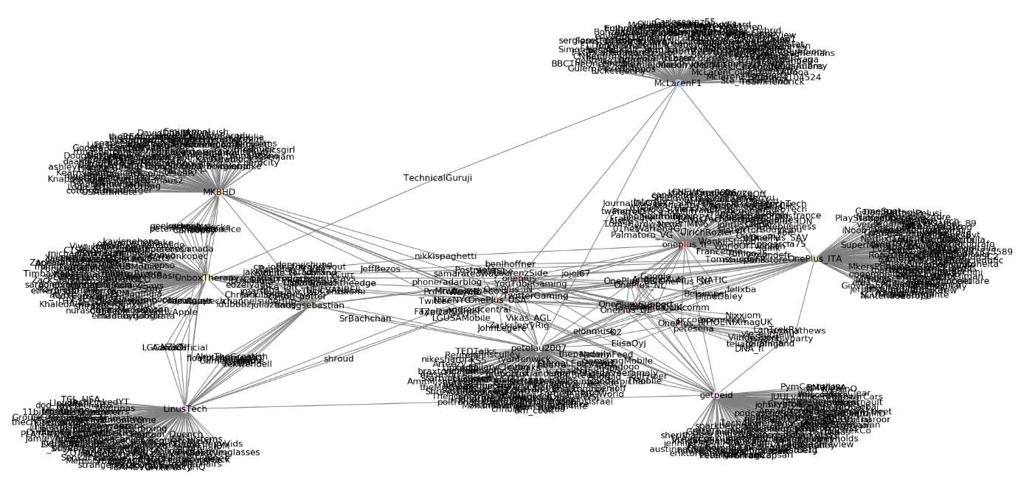

There are a few centrality measurements that can be derived from the graph above. Mainly degree, betweenness and eigenvector centrality. The top 5 friends of each centrality measure is recorded.

**Degree Centrality**

|  |  |  |
| --- | --- | --- |
| **No.** | **Friend** | **Degree Centrality** |
| 1 | @OnePlus_ITA | 108 |
| 2 | @getpeid | 108 |
| 3 | @petelau2007 | 107 |
| 4 | @LinuesTech | 104 |
| 5 | @MKBHD | 104 |

From result, it shows that Carl Pei (@getpeid), who is the co-founder, and Pete Lau (@petelau2007), who is the founder, are the most attached in the network because they followed the most users within the network. This is because they might be concerned about their business and thus following users that are related to OnePlus. Reviewers also might follow @getpeid and @petelau2007 as well as they are to anticipate any latest announcement from them. One the other hand, @LinusTech and @MKBHD, who are smartphone reviewers, have high degree centralities because they might follow similar domain users as well.

**Betweenness Centrality**

|  |  |  |
| --- | --- | --- |
| **No.** | **Friend** | **Betweenness Centrality** |
| 1 | @petelau2007 | 0.24804 |
| 2 | @OnePlus_ITA | 0.23854 |
| 3 | @getpeid | 0.23113 |
| 4 | @McLarenF1 | 0.22990 |
| 5 | @LinusTech | 0.21905 |

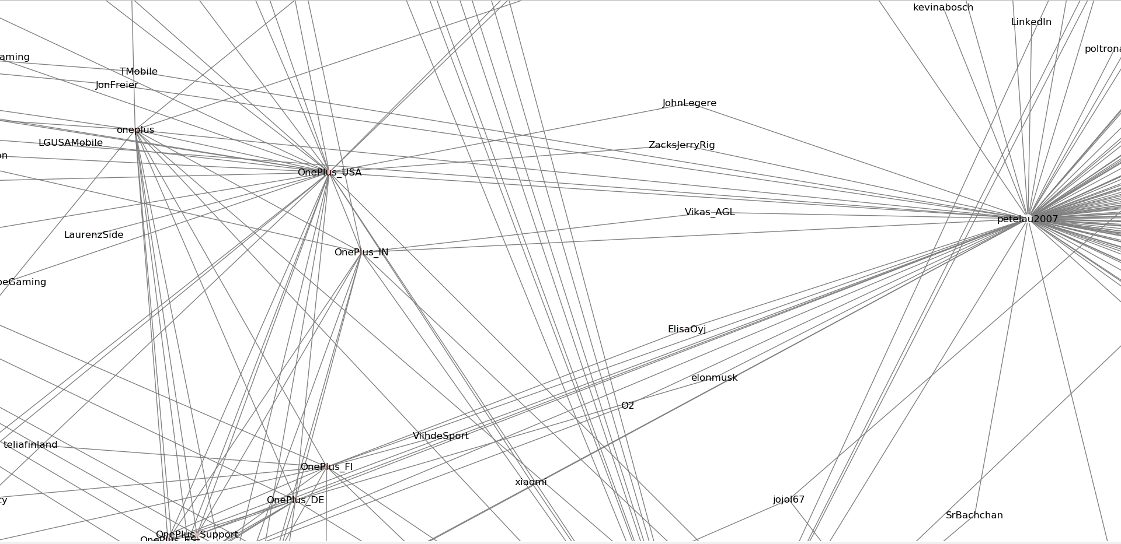

From the figure above, it shows that @petelau2007 is responsible to connect his community to other communities including @OnePlus_USA, @OnePlus_IN, @OnePlus_FI and six other similar OnePlus accounts. Therefore, @petelau2007 acts as a bridge for a lot of the communities to reach his own communities, which is why the betweenness centrality is the highest.

**Eigenvector Centrality**

|  |  |  |
| --- | --- | --- |
| **No.** | **Friend** | **Eigenvector Centrality** |
| 1 | @petelau2007 | 0.33295 |
| 2 | @OnePlus_ITA | 0.31417 |
| 3 | @oneplus_fr | 0.29152 |
| 4 | @getpeid | 0.26044 |
| 5 | @OnePlus_USA | 0.24230 |

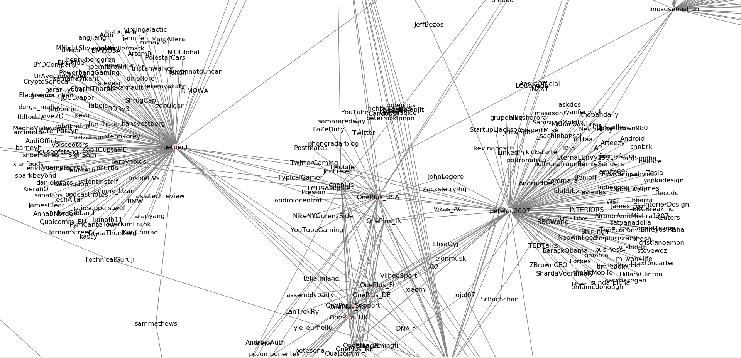

The graph above shows the community of three of the top five eigenvector centrality, which are @petelau2007, @getpeid and @OnePlus_USA. They have the highest eigenvector centrality measure because they are connected to one of the most important friend, which is @petelau2007, and they are situated in the middle of the entire network. Since @petelau2007 has the highest betweenness centrality because it is an important friend that acts as a bridge to other users, @getpeid and @OnePlus_USA has a high eigenvector centrality as well as they are connected to @petelau2007.

The friends that are followed by OnePlus are noticeable and are generalized as below:

1. OnePlus Founder and Co-Founder

* @getpeid
* @petelau2007

1. Mobile phones and tech gadgets reviewers on Youtube

* @MKBHD
* @LinusTech
* @UnboxTherapy

1. Other OnePlus account of different countries

* @oneplus_fr (France)
* @OnePlus_IN (India)
* @OnePlus_ES (Spain)

1. Automobile
   * @McLarenF1

On the left portion of the graph, the reviewers of mobile phones and tech gadgets on Youtube are shown clustered together although all four of them are of the different communities. This is because they share some of the similar second-level friends since they are of the same industries. The subgraph of the reviewers are shown as below.

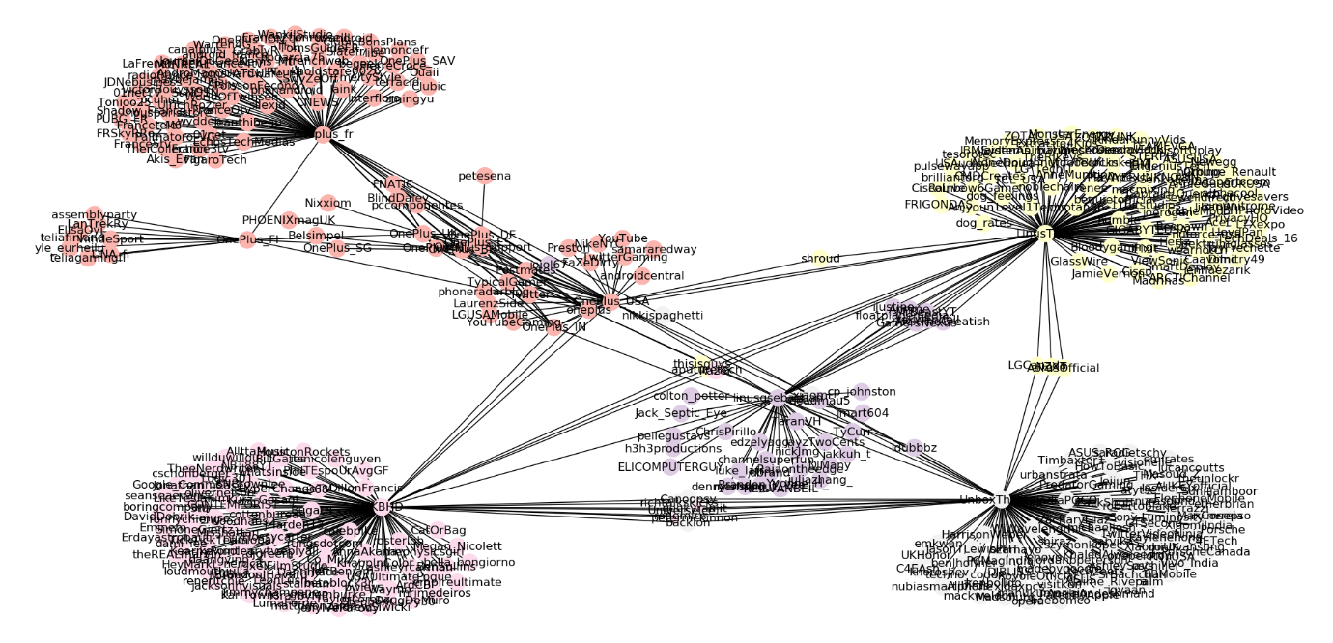

Firstly, the reviewer subgraph contains four communities, excluding oneplus (dark pink community), with central nodes of @MKBHD (pink community), @LinusTech (yellow community), @linusgsebastian (purple community) and @UnboxTherapy (white community). This shows that OnePlus is concerned about the comments and opinions of reviewers by following them on Twitter. By following the reviewers on Twitter, OnePlus might discover videos of reviews on one of their products and use it as an advertisement to endorse their products on different social media platform. Besides, another motive of following tech reviewers on Twitter is that it can help OnePlus to study other social media campaigns by other companies.

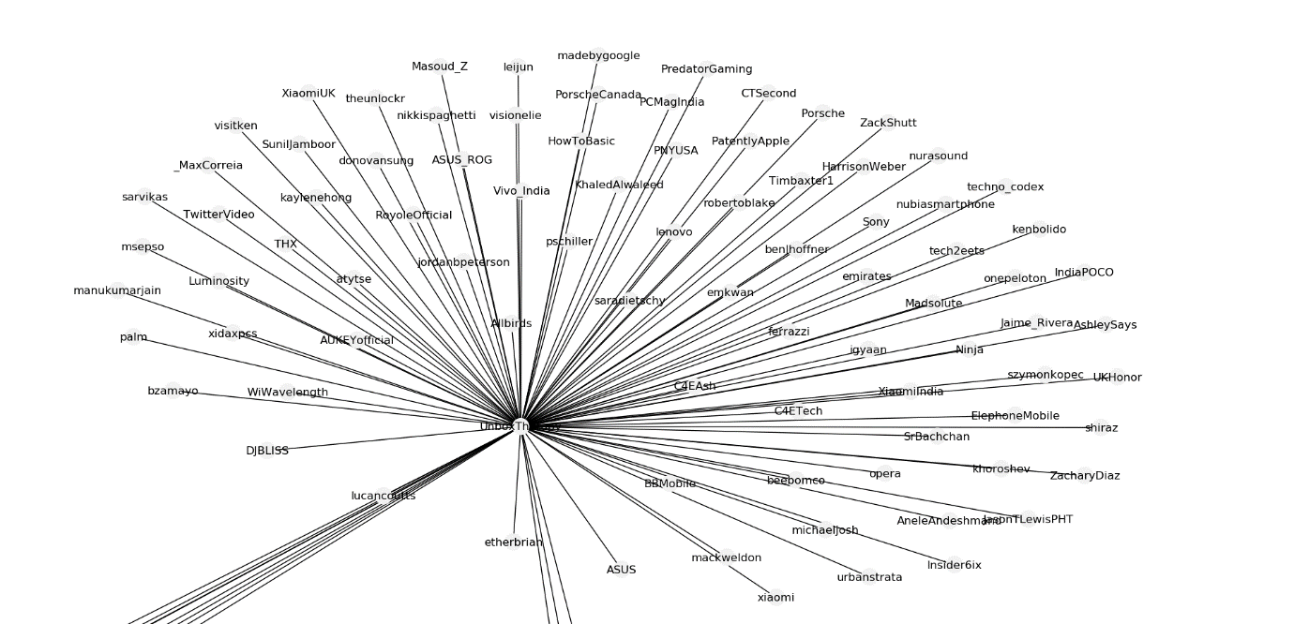

The figure above is the community of @UnboxTherapy. From the community, we can see that @UnboxTherapy follows other companies of the same domain as OnePlus such as @Vivo_India, @xiaomi, @indiaPOCO and @ASUS_ROG. These mentioned companies are also smartphone manufacturers that produces smartphones. Therefore, whenever @UnboxTherapy retweets or replies to any tweets of those companies, OnePlus can view the tweet indirectly and study their social media campaign strategy. For instance, @Vivo_India heavily promotes their smartphone Vivo V15 Pro through their hashtag #VivoV15Pro and #GoPop, which is a hashtag for their new pop-up front camera that they are using as a selling point. This hashtag campaign to promote their specific product is very similar to what OnePlus has done with their OnePlus 6T model.

Other than the reviewer communities, OnePlus also followed a friend from an automobile industry, which is @McLarenF1. The subgraph of the community is illustrated as below.

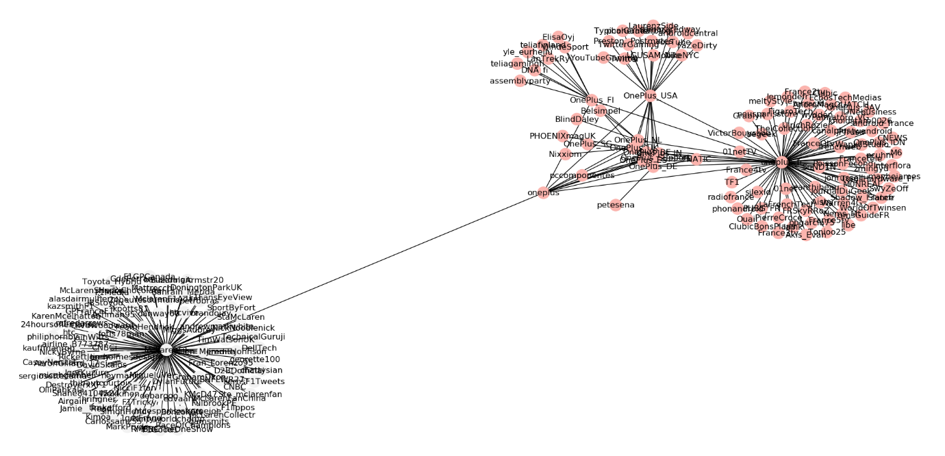

From the subgraph, the white community represents @McLarenF1’s community. This shows that OnePlus had some partnership with @McLarenF1 in the past. For instance, they have once collaborated together to release a McLaren Edition of OnePlus 6T to promote both brands at once. Thus, fans from the gadget community and fans from automobile community can be easily exposed both brands and potentially be interested to it.

In addition to that, OnePlus following @McLaren can potentially bring benefits for them in the future as well. This assumption can be further illustrated in the community of @McLarenF1 shown below.

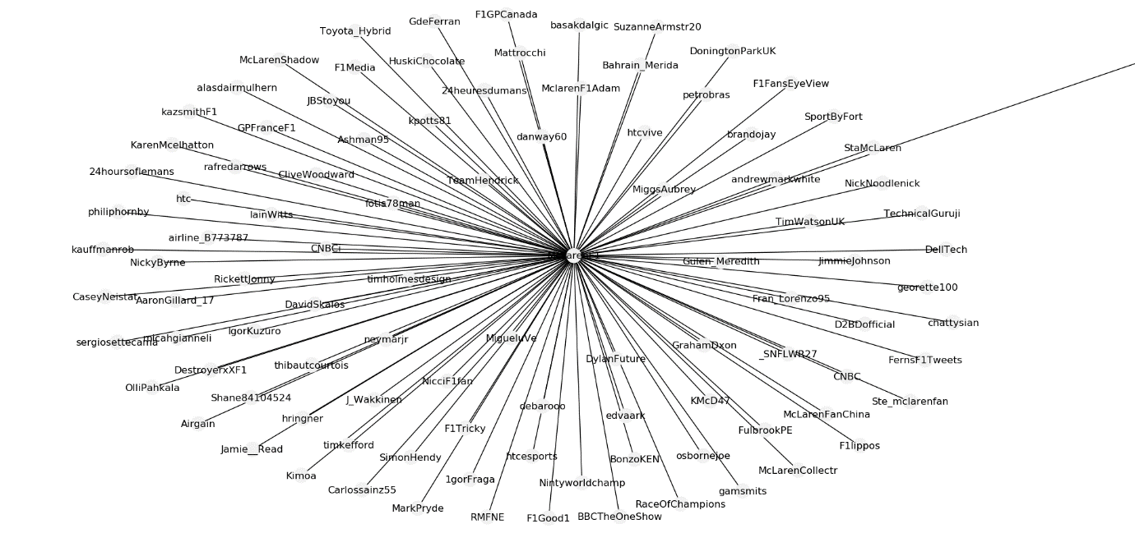

The community above shows that @McLarenF1 had followed Jimmie Johnson (@JimmieJohnson), who is a professional racer, and Hendrick Motorsports (@TeamHendrick), which is an American professional car racing team. So through @McLarenF1, OnePlus might get to know both of them and conduct some marketing strategy with them. For example, OnePlus might seek for endorsement with Jimmie Johnson once they get to know them better through tweets from @McLarenF1 in the future. Another possibility is that OnePlus can sponsor Hendrick Motorsports and have their logo stuck on cars used by Hendrick Motorsports as an exposure of brands.

**SamsungMobile Friends Communities**

SamsungMobile on Twitter originally follows 436 other users but in our Social Network Analysis, only 50 friends and 100 friends of friends of SamsungMobile will be used for this analysis. The overall graph contains 4423 nodes and 4648 edges with the density of 0.000475. So the statistics shows that the graph is quite sparse and not much of the nodes are connected to each other, signifying that most of the friends in different communities do no follow each other. The graph below shows the friends communities of SamsungMobile.

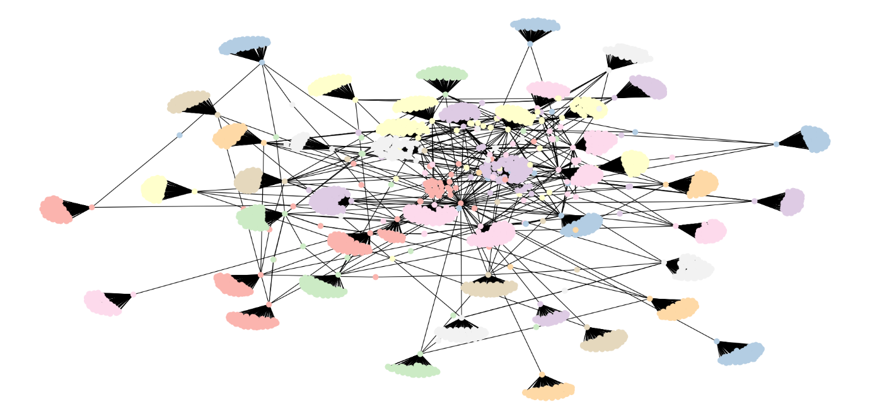

The degree, betweenness and eigenvector centrality from the network graph above are recorded as well. The top 5 friends of each centrality measure is illustrated.

**Degree Centrality**

|  |  |  |
| --- | --- | --- |
| **No.** | **Friend** | **Degree Centrality** |
| 1 | @TwitterVideo | 107 |
| 2 | @MKBHD | 104 |
| 3 | @SamsungMobileUS | 103 |
| 4 | @SamsungAU | 103 |
| 5 | @ChrisEvans | 103 |

From the list of the top five degree centrality, @TwitterVideo has the highest degree centrality as it is a common account by Twitter that posts random videos. The second highest degree centrality friend is @MKBHD. This is probably due to other friends of similar industry or interest might follow each other in the network.

**Betweenness Centrality**

|  |  |  |
| --- | --- | --- |
| **No.** | **Friend** | **Betweenness Centrality** |
| 1 | @SamsungMobile | 0.89393 |
| 2 | @TwitterVideo | 0.04893 |
| 3 | @JChengWSJ | 0.04516 |
| 4 | @SamsungMobileEK | 0.04516 |
| 5 | @Lil_Eazy_Ana_42 | 0.04494 |

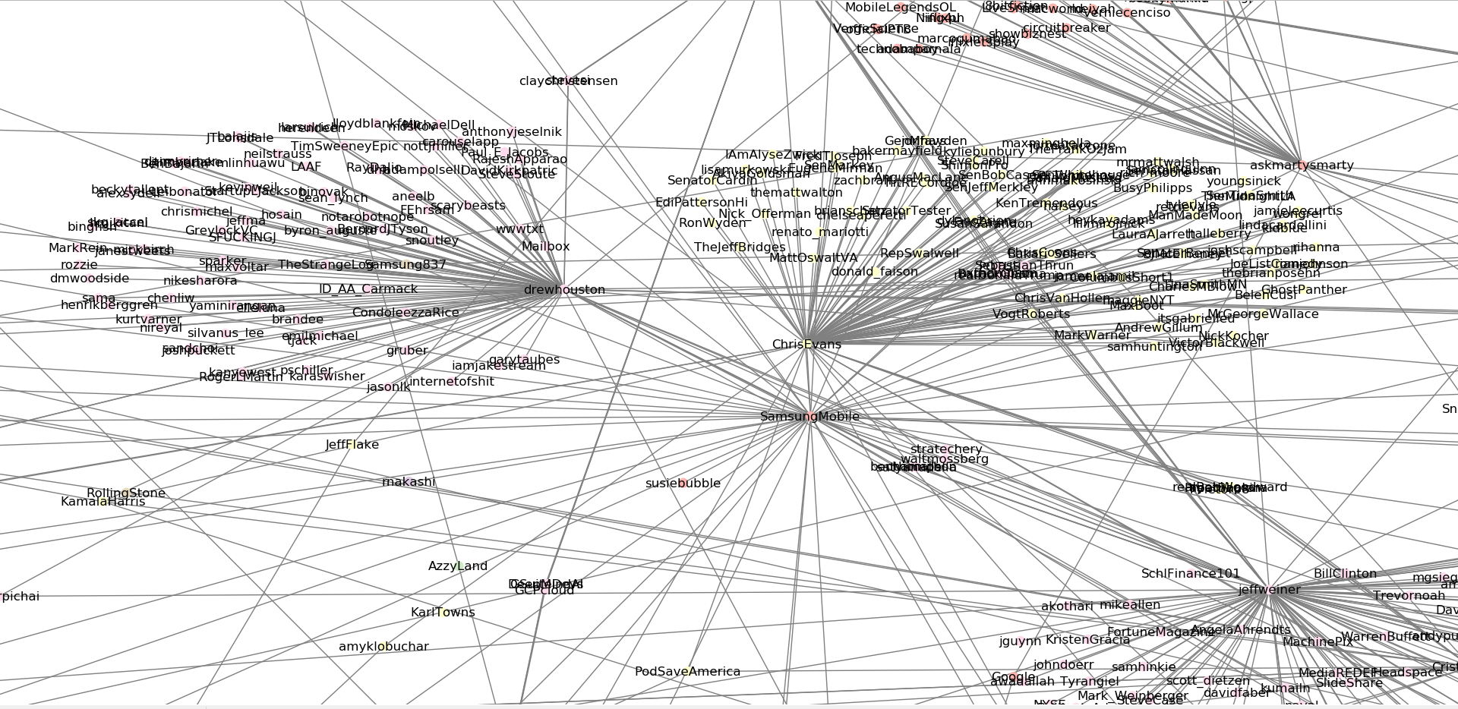

@SamsungMobile has a significantly higher betweenness centrality compared to the other friends. This is probably due to @SamsungMobile situating in the middle of the network, which acts as a bridge to connect most of the other communities to the other. This shows that other communities might differ from each other as they do not have any other friends following friends from other communities.

**Eigenvector Centrality**

|  |  |  |
| --- | --- | --- |
| **No.** | **Friend** | **Betweenness Centrality** |
| 1 | @SamsungMobile | 0.35431 |
| 2 | @jeffweiner | 0.24380 |
| 3 | @drewhouston | 0.20887 |
| 4 | @marissamyer | 0.18349 |
| 5 | @TwitterVideo | 0.17638 |

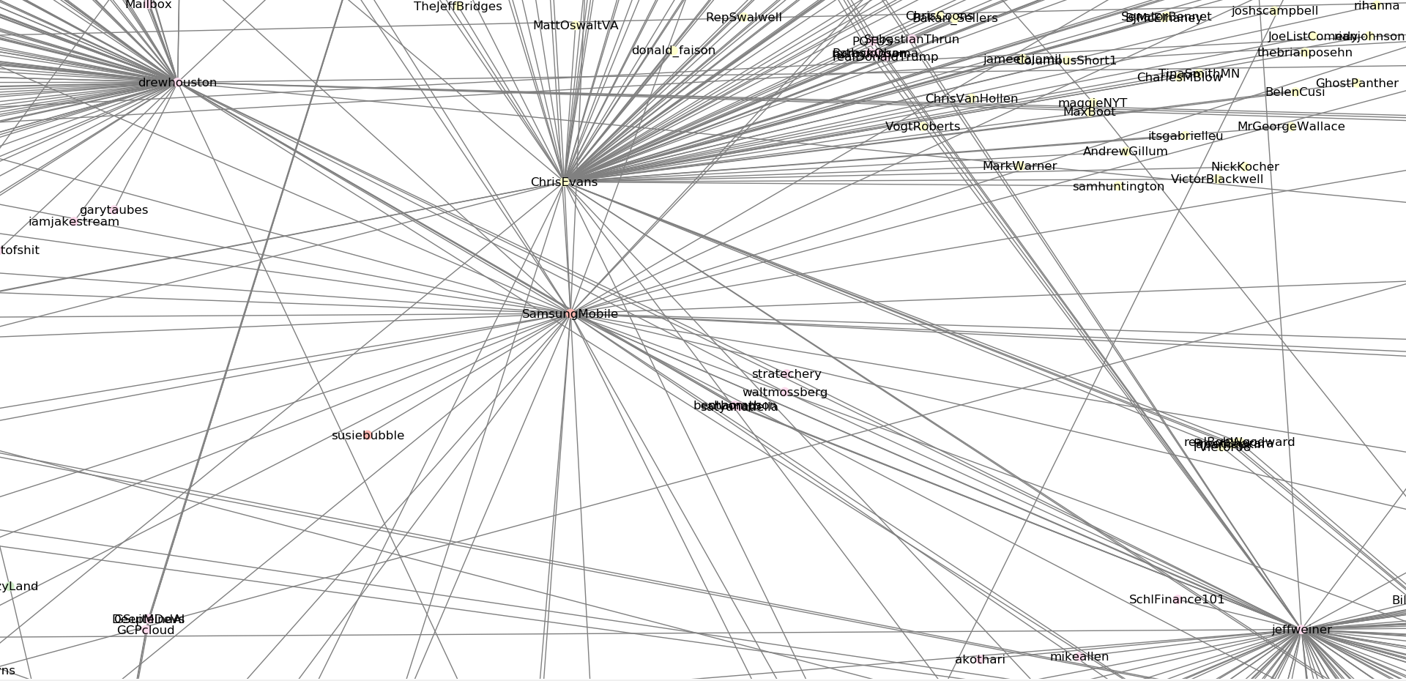

@SamsungMobile has the highest eigenvector centrality probably because it is acts an important bridge to connect communities as it has the highest betweenness centrality. Since @jeffweiner and @drewhouston are directly next to @SamsungMobile, their eigenvector centrality will be higher as well.

SamsungMobile has followed many users, the more notable friends that are followed by SamsungMobile are generalized as below:

1. Grand Events

* @Olympics
* @CES

1. Public Figures

* @f_cancelllera
* @ChrisEvans
* @Shelley__Watts
* @akiyamayoshihir

1. Gamers on Youtube

* @TypicalGamer
* @iHasCupquake

1. Mobile phones and tech gadgets reviewers on Youtube

* @AndroidAuth
* @MKBHD

1. Accessory Makers

* @deGRISOGONO

1. Other Samsung account of different countries

* @Samsung_IN (india)
* @SamsungAU (Australia)
* @Samsung_Pak (Pakistan)
* @SamsungMobileUS (USA)

Multiple subgraphs will be plotted in order to provide details on the friends network of SamsungMobile.

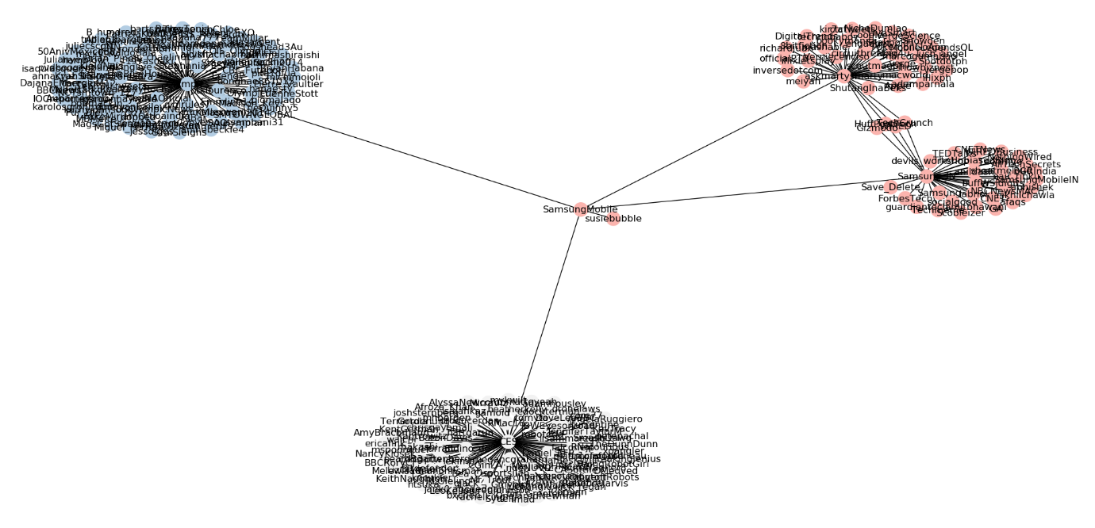

The subgraph above shows the relationship between SamsungMobile, @CES (white community) and @Olympics (blue community), which illustrates that SamsumgMobile has followed both of them. This shows that SamsungMobile’s strategy to promote their brand or any device might involve sponsoring an event or even through an announcement in a major event. Samsung might be sponsoring the Olympics with their goods and even release a smartphone of their brand with an Olympics limited edition, promoting the Olympics and their brand at the same time. Moreover, the Consumer Electronics Show (CES) is an event that allows various companies to showcase their innovation or gadgets. Samsung that is following @CES on Twitter might indicate that they uses that showcase as a platform to make any announcements on their most innovative and latest release.

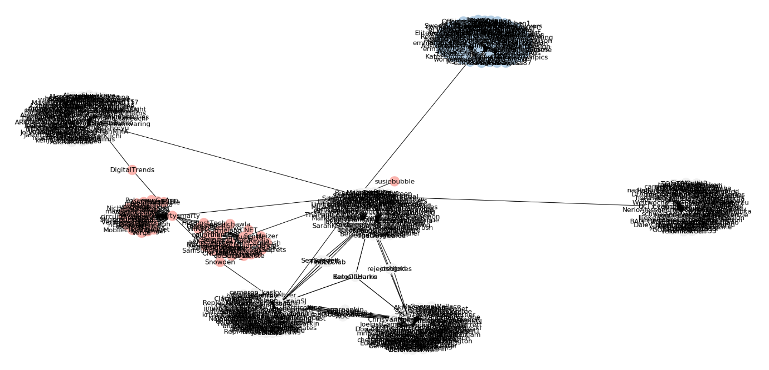

The subgraph above illustrates the relationship of SamsungMobile and the public figures that they follow. This relationship might indicate that Samsung has used Public Figures as their ambassador to potentially attract more new customers from their fan base. For instance, SamsungMobile has shot an advertisement with @akiyamayoshihir (white community), who is a famous Korean fighter, for the release of their limited edition smartphone, Samsung Galaxy S6 Marvel: Avengers Edition. Besides, Samsung also appointed @ChrisEvans (blue community), an actor, to be the ambassador of Samsung. Therefore, the subgraph above might show SamsungMobile’s effort in promoting their device through the exposure along with public figures.

The network of public figure friends is also useful as well since public figures are often friends with other celebrities on Twitter.

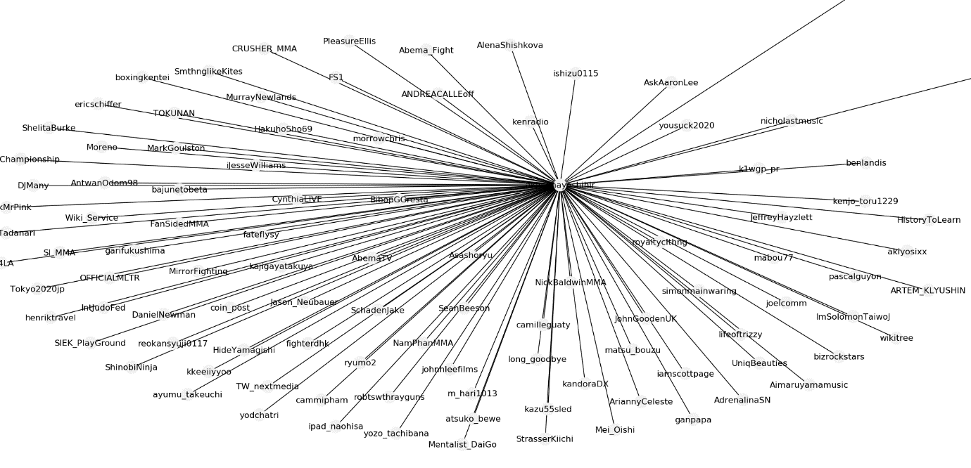

The graph about illustrates the friends of Choo Sung Hoon (@akiyamayoshihir). The graphs shows that there are members such as Daniel Newman (@DanielNewman), who is an actor. This can be useful for SamsungMobile as they can easily look for their next potential ambassador whenever @akiyamayoshihir retweets or replies on tweets of @DanielNewman. Thus, SamsungMobile might get to know @DanielNewman through @akiyamayoshihir and might select a new suitable ambassador to promote their brand.

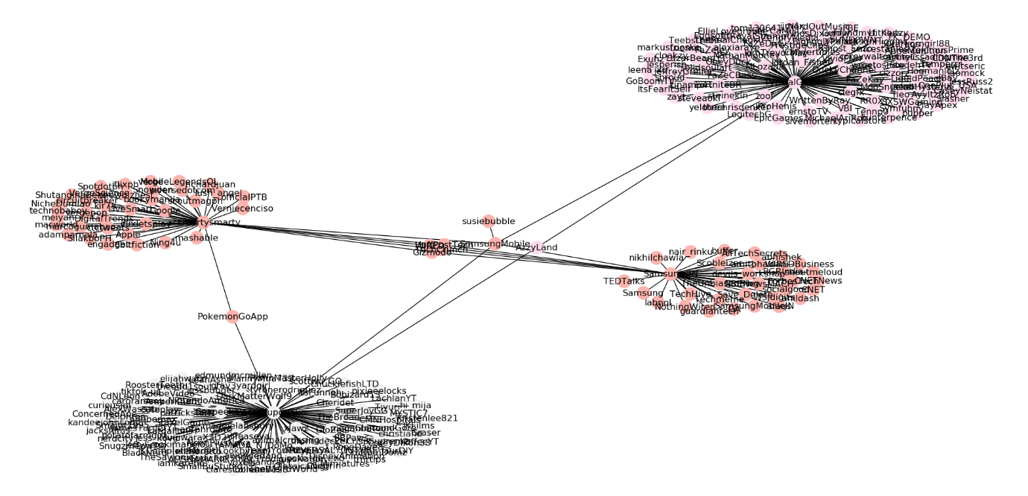

The subgraph above shows the friends relationship of SamsungMobile with two gamers on Youtube, which are @iHasCupquake (white community) and @TypicalGamer (pink community). SamsungMobile following these two friends also indicates that they had a partnership or collaboration. Since both of them are gamers on Youtube, SamsungMobile can send them a sample of their latest smartphone or gadgets and ask them to review the gaming experience on it. The words and reviews that are raised by them can be a useful marketing method to expose their brand to more handheld gamers and subscribers of them.

Since both of these gamer friends of SamsungMobile posts video of them playing games on Youtube as their main purpose of the channel, the friends that they follow might be of the same industry and SamsungMobile can slightly be benefited from it. The graph below shows the friends of @iHasCupquake.

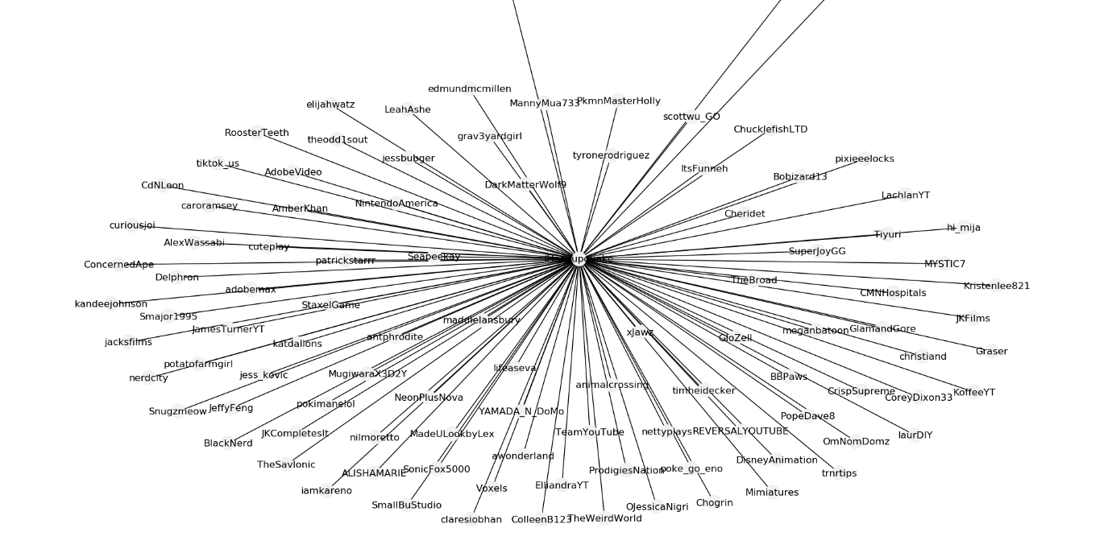

From @iHasCupquake’s community, we can see notice other gaming Youtube creators such as @LachlanYT and @JamesTurnerYT. Once again, whenever @iHasCupquake reacts to posts of them, SamsungMobile can notice them easily and might seek for a partnership or even send them a sample and ask them to review the gaming experience of it.

Morevoer, Samsung also follows de Grisogono (@deGRISOGONO), which is a Swiss Luxury jeweller, on Twitter. The subgraph of the relationship between SamsungMobile and @deGRISOGONO is illustrated below.

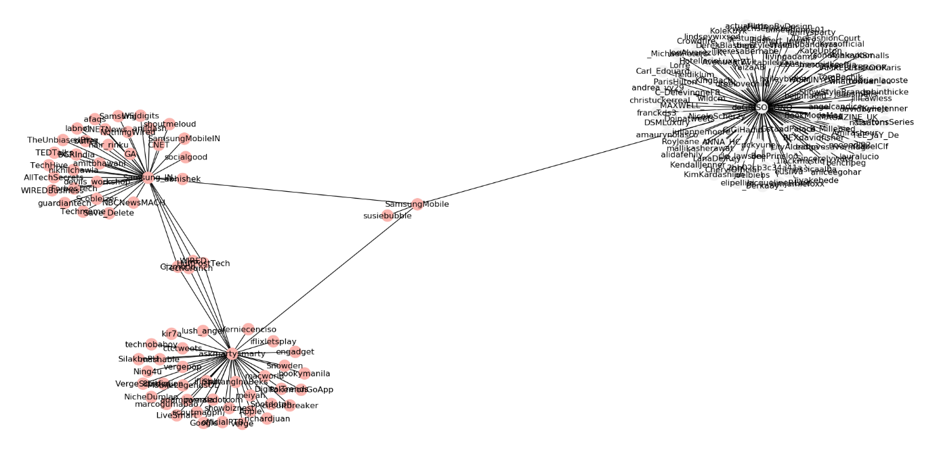

This relationship might signify a potential partnership between them. SamsungMobile might seek for a collaboration with them by designing a luxury smartphone with jewels decorated around it, similar to what they have done in the past with Samsung Gear S2, which is Samsung’s smartwatch.

The friends of @deGRISOGONO’s community might be provide benefits to SamsungMobile indirectly as well. The community of @deGRISOGONO is shown as below.

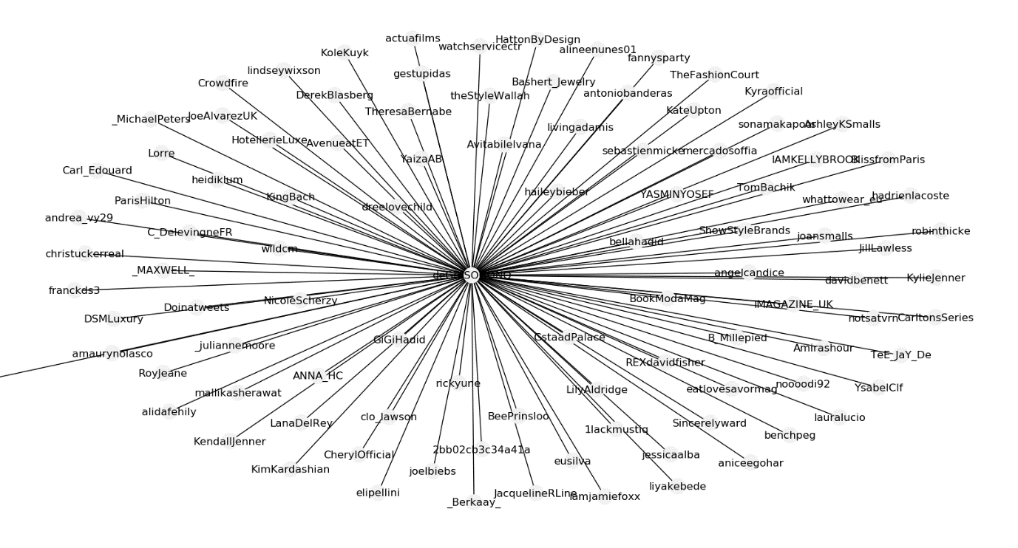

From the community, we can notice that the jeweller follows celebrities such as King Bach (@KingBach) and Kim Kardashian (@KimKardashian). Therefore, SamsungMobile can also indirectly associate with them and potentially seek for endorsement partnership with them.

Lastly, SamsungMobile also follows Youtube tech and smartphone reviewers on Twitter too, the reviewers include @AndroidAuth and @MKBHD. The relationship might shows that SamsungMobile take public opinion on their brands and products seriously, so they follow reviewers to get their opinion on them. The subgraph of the relationship between SamsungMobile and the reviews are illustrated as below.

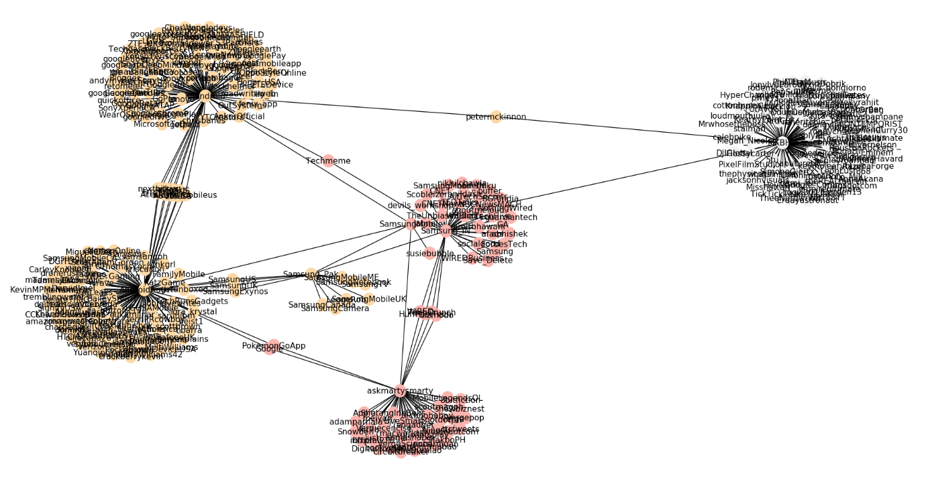

From the subgraph, we can see that the relationship between SamsungMobile along with @AndroidAuth and @MKBHD is quite closely related. Many of the friends that they are following, followed other friends of other communities. For instance, between @AndroidAuthority’s community (orange community) and SamsungMobile’s community (pink community), many of the friends acts as a connector between both communities such as @Techmeme, @Google, @PokemonGoApp and @Samsung_Pak. The relationship is slight denser than other subgraphs is because @MKBHD and @AndroidAuth are of similar industry that are working on similar things, thus their communities might be similar in some ways.

Besides, SamsungMobile following those friends might bring other benefits as well. The community of @AndroidAuth is illustrated as below to better prove the benefit in detail.

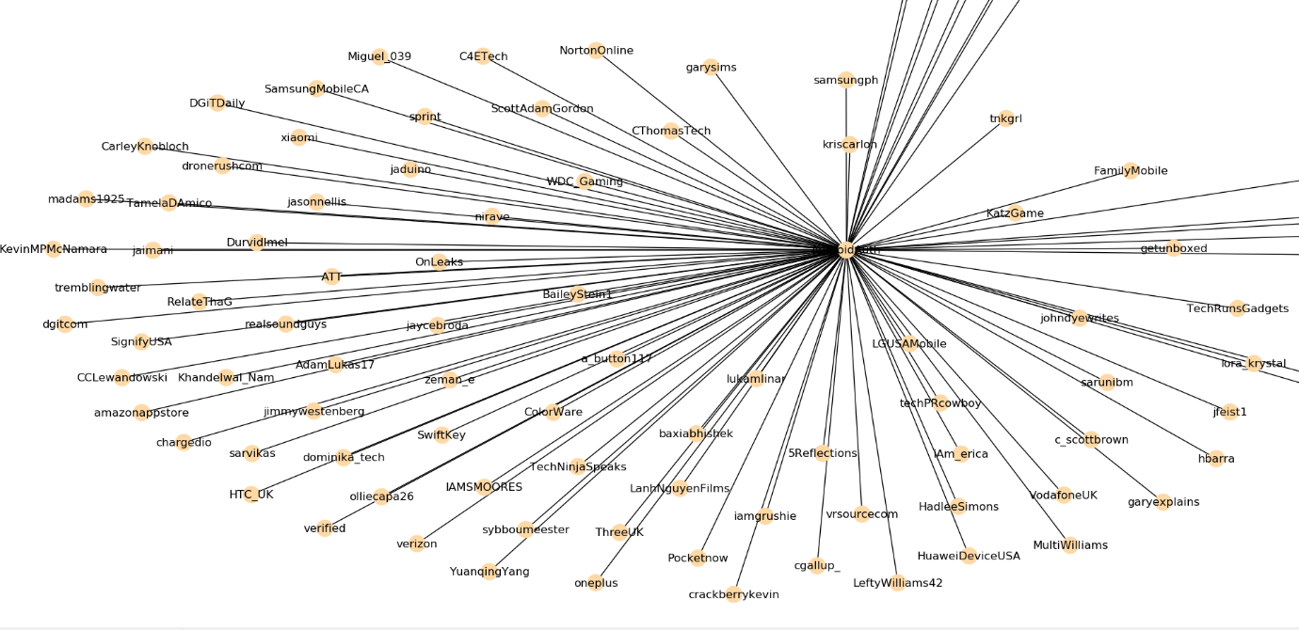

From @AndroidAuth’s community, we can see there are friends of identify domain to SamsungMobile, such as @HTC_UK, @xiaomi, @LGUSAMobile and most important our selected competitor in the analysis, @oneplus. From there, SamsungMobile might be able to learn and study some techniques for social media campaign through following @AndroidAuth. For instance, the hashtag campaign of @oneplus to promote their flagship smartphone, OnePlus 6T with #OnePlus6T is very similar to SamsungMobile’s strategy to promote Galaxy Note 9 with #GalaxyNote9. Therefore, following tech and smartphone reviewers might be crucial to improve one’s social media campaign strategy through indirectly observing their rival companies.

# Conclusion

In conclusion, the friends network of SamsungMobile consist of more diverse and variety of communities from different domains and industries in comparison to OnePlus’ network. Communities of OnePlus consists of mostly their own founder and co-founder and OnePlus’ of other countries communities, a few tech and smartphone reviewers and one from the automobile industry while SamsungMobile’s network consist of different communities such as reviewers, accessory makers, public figures, gamers on Youtube and a couple of major events. Therefore, SamsungMobile managed to market and promote their brand and products to people from different communities thus expanding their chances of exposure.

In addition to that, SamsungMobile has used various method to promote their brand such as finding endorsements and ambassadors from public figures, seeking partnerships with gamers on social media, sponsoring grand events and also announcing their technologies in an event showcase. On the other hand OnePlus’ promotional technique are limited to mostly creating advertisements and sponsoring reviewers on Youtube and some collaboration with an automobile company to launch a limited edition of their smartphone.

Thus, although SamsungMobile and OnePlus has some strategy in common, such as launching limited edition of their devices and following reviewers to get opinions from the public, SamsungMobile still managed to take a notch higher of their promotional strategy by sponsoring huge events and collaboration with public figures, gamers and accessory makers. These strategies taken by SamsungMobile can help exposing their brand to communities of different interest and potentially gain more customers. Therefore, it is safe to assume that SamsungMobile had a better network and marketing strategy than OnePlus when it comes to promoting their brand and product.